**BOOK CATEGORY**

**Thriller :**

Tittle: The Silent Patient :

Write: Novel by Alex Michaelides :

**Description**: The Silent Patient is a 2019 psychological thriller novel written by British–Cypriot author Alex Michaelides. The debut novel was published by Celadon Books, a division of Macmillan Publishers, on 5 February 2019. The audiobook version, released on the same date, is read by Louise Brealey and Jack Hawkins.

**Year:** February 5, 2019

[**Original language**](https://www.google.com/search?sa=X&sxsrf=ALiCzsYfv1CLKQbgs5DcO6DgaJerlbRKHg:1659550755318&q=the+silent+patient+original+language&stick=H4sIAAAAAAAAAOPgE-LVT9c3NEwzjTeLL0wx1hLLTrbST8rPzwYTVjmJeemliempi1hVSjJSFYozc1LzShQKEksyQXR-UWZ6Zl5ijgJMGQAUOxg2UAAAAA&ved=2ahUKEwjGnYeqpKv5AhXlZWwGHb4oAN8Q6BMoAHoECGgQAg&cshid=1659550759603739)**:**English

**IMAGE**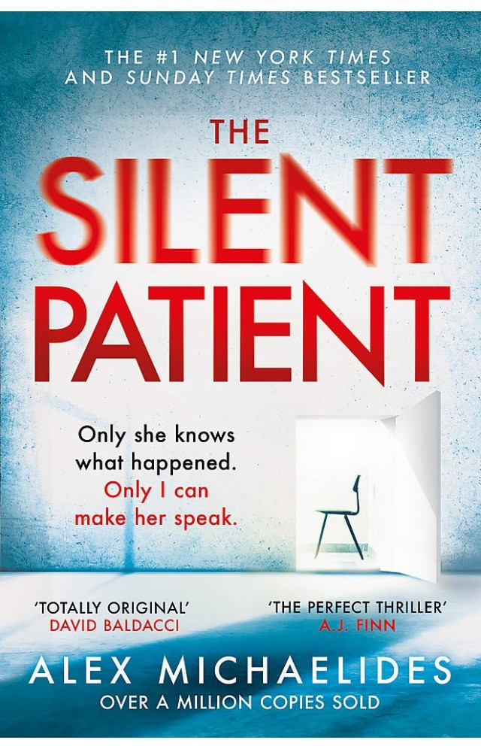

**Thriller**

Tittle: Gone Girl:

Write by: Novel by Gillian Flynn

DISCRIPTION: Gone Girl is a 2012 crime thriller novel by American writer Gillian Flynn. It was published by Crown Publishing Group in June 2012. The novel was popular and made the New York Times Best Seller list. The sense of suspense in the novel comes from whether Nick Dunne is responsible for the disappearance of his wife Amy.

Year: May 24, 2012

[**Original language**](https://www.google.com/search?cs=0&sxsrf=ALiCzsaEisiiTcdryw0vMLcF5GqL3Shzjw:1659550942800&q=gone+girl+novel+original+language&stick=H4sIAAAAAAAAAOPgE-LSz9U3yIrPrqio0BLLTrbST8rPzwYTVjmJeemliempi1gV0_PzUhXSM4tyFPLyy1JzFPKLMtMz8xJzFGBqAFBEAPdKAAAA&sa=X&ved=2ahUKEwiGsLiDpav5AhVj_bsIHV4fACUQ6BMoAHoECGsQAg)**:**English

IMAGE

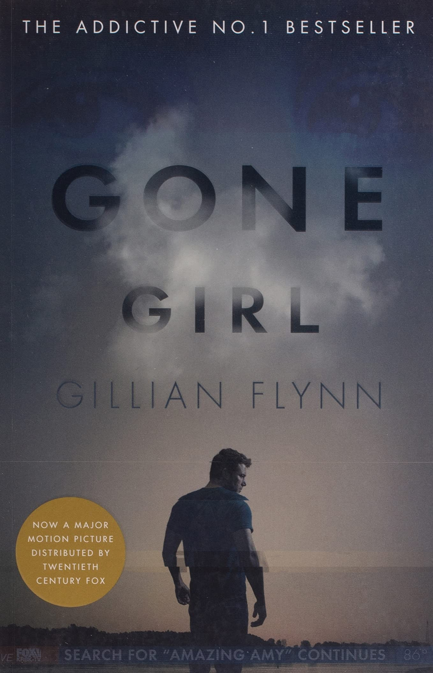

**Thriller**

Verity

WRITTE: Book by Colleen Hoover

DESCRIPTION: **Ew York Times BestsellerUSA Today BestsellerThe Globe and Mail BestsellerPublishers Weekly BestsellerWhose truth is the lie? ...**

YEAR: December 7, 2018

[**Nominations**](https://www.google.com/search?cs=0&sxsrf=ALiCzsaVMl9aZFCwoxByoxiezbRCNX46rQ:1659551879636&q=verity+nominations&stick=H4sIAAAAAAAAAOPgE-LVT9c3NEzLMqrIKMhL0lLKTrbSTyxPLEqBkPHlmXl5qUVWefm5mXmJJZn5ecWLWIXKUosySyoVkAQB42lIjkoAAAA&sa=X&ved=2ahUKEwiVjYbCqKv5AhUXYPEDHUd0ANYQ6BMoAHoECGcQAg)**:**[Goodreads Choice Awards Best Romance](https://www.google.com/search?cs=0&sxsrf=ALiCzsaVMl9aZFCwoxByoxiezbRCNX46rQ:1659551879636&q=Goodreads+Choice+Awards+Best+Romance&stick=H4sIAAAAAAAAAOPgE-LVT9c3NEzLMqrIKMhLUoJwk0pyjdPSDOO1lLKTrfQTyxOLUiBkfHlmXl5qkVVefm5mXmJJZn5e8SJWFff8_JSi1MSUYgXnjPzM5FQFR5DaYgWn1OIShaD83MS85NQdrIy72Jk4GAAQP4hhcwAAAA&sa=X&ved=2ahUKEwiVjYbCqKv5AhUXYPEDHUd0ANYQmxMoAXoECGcQAw)

[**Genres**](https://www.google.com/search?cs=0&sxsrf=ALiCzsaVMl9aZFCwoxByoxiezbRCNX46rQ:1659551879636&q=verity+genres&stick=H4sIAAAAAAAAAOPgE-LVT9c3NEzLMqrIKMhL0hLOTrbST8rPzwYTVumpeUWpi1h5y1KLMksqFcDcYgCJH5pYNgAAAA&sa=X&ved=2ahUKEwiVjYbCqKv5AhUXYPEDHUd0ANYQ6BMoAHoECGYQAg)**:**Novel, Thriller, Romance novel, Fiction, Suspense

**IMAGE**

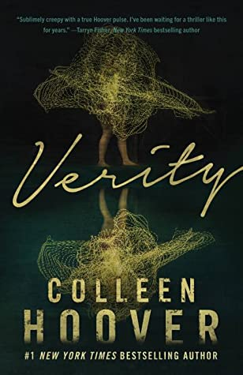

**Thriller:**

Tittle: The Girl on the Train

WRITTE: Novel by Paula Hawkins

DISCRIPTION: The Girl on the Train is a 2015 psychological thriller novel by British author Paula Hawkins that gives narratives from three different women about relationship troubles and, for the main protagonist, alcoholism. wiki

YEAR: January 6, 2015

[**Original language**](https://www.google.com/search?cs=0&sxsrf=ALiCzsZrqBTcHHZOguHgmAPXPKzZjdKnsw:1659553047455&q=the+girl+on+the+train+novel+original+language&stick=H4sIAAAAAAAAAOPgE-LVT9c3NEwyzalMyzU01hLLTrbST8rPzwYTVjmJeemliempi1h1SzJSFdIzi3IU8vMUQOySosTMPIW8_LJUoFBRZnpmXmKOAkw9AL-xiCtZAAAA&sa=X&ved=2ahUKEwjX0fjurKv5AhUKqaQKHWfGCCkQ6BMoAHoECF0QAg)**:**English

**IMAGE**

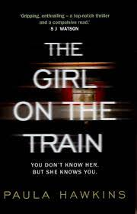

**HOROOR:**

**Tittle:** House of Leaves

WRITTE: Novel by Mark Z. Danielewski

Discription: House of Leaves is the debut novel by American author Mark Z. Danielewski, published in March 2000 by Pantheon Books. A bestseller, it has been translated into a number of languages, and is followed by a companion piece, The Whalestoe Letters.

Year: March 7, 2000

[**Original language**](https://www.google.com/search?rlz=1C1GCEU_enPK864PK864&cs=0&sxsrf=ALiCzsYkgE0Bx-gOvX6PD4OE9jy_s3oSmA:1659711159006&q=house+of+leaves+original+language&stick=H4sIAAAAAAAAAOPgE-LQz9U3yE0pMdcSy0620k_Kz88GE1Y5iXnppYnpqYtYFTPyS4tTFfLTFHJSE8tSixXyizLTM_MScxRgagAtLVOWSAAAAA&sa=X&ved=2ahUKEwjm_77w-a_5AhUkgv0HHZL8DUEQ6BMoAHoECGYQAg)**:**English

IMAGE:

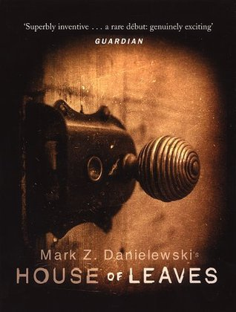

**HOROOR:**

**Tittle:** The Haunting of Hill House

**write:** Novel by Shirley Jackson

Discription: The Haunting of Hill House is a 1959 gothic horror novel by American author Shirley Jackson. A finalist for the National Book Award and considered one of the best literary ghost stories published during the 20th century, it has been made into two feature films and a play, and is the basis of a Netflix series.

Year: 1959

IMAGE:

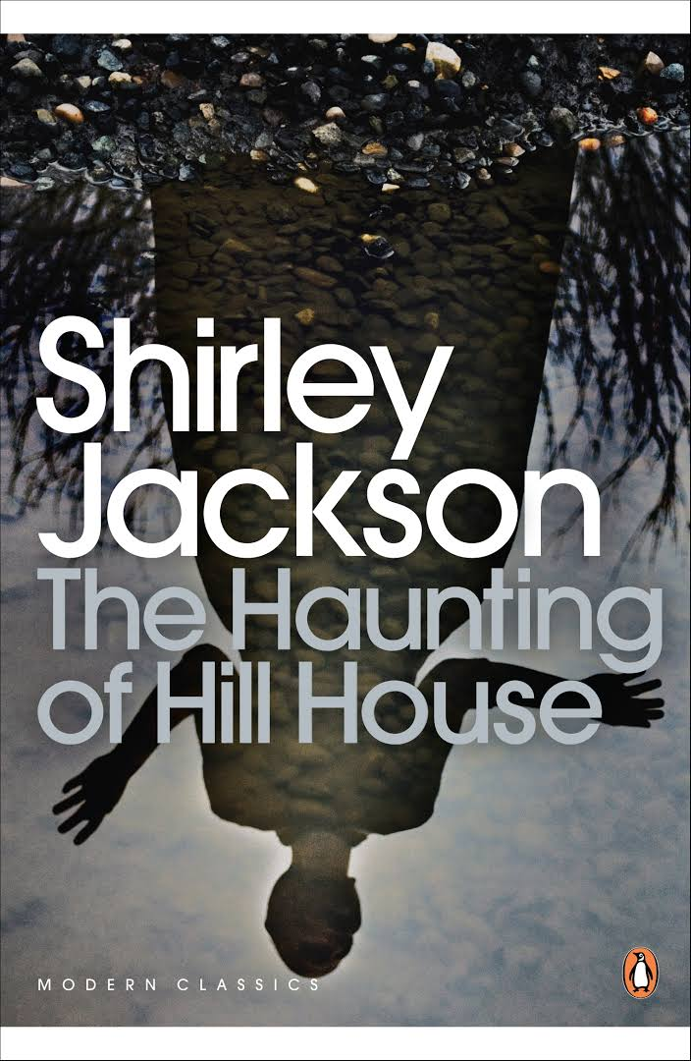

**HOROOR:**

**Tittle:** The Shining

Write: Novel by Stephen King

Discription: The Shining is a 1977 horror novel by American author Stephen King. It is King's third published novel and first hardback bestseller; its success firmly established King as a preeminent author in the horror genre.

Year: January 28, 1977

[**Original language**](https://www.google.com/search?rlz=1C1GCEU_enPK864PK864&cs=0&sxsrf=ALiCzsbutgrqdqrpuV6lJR8VcDCvP02bpw:1659712260988&q=the+shining+novel+original+language&stick=H4sIAAAAAAAAAOPgE-LQz9U3ME8uK9ISy0620k_Kz88GE1Y5iXnppYnpqYtYlUsyUhWKMzLzMvPSFfLyy1JzFPKLMtMz8xJzFGCqAI8x8sxKAAAA&sa=X&ved=2ahUKEwiihfv9_a_5AhVkXvEDHYjzDWgQ6BMoAHoECFwQAg)**:**English

IMAGE:

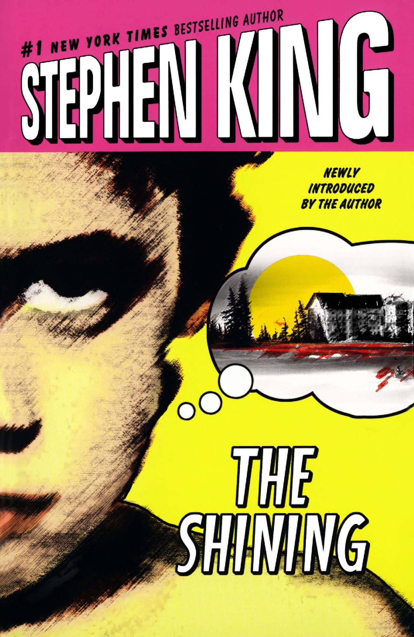

**HOROOR:**

**Tittle:** Dracula

Tittle: Novel by Bram Stoker

Discription: Dracula is a novel by Bram Stoker, published in 1897. As an epistolary novel, the narrative is related through letters, diary entries, and newspaper articles. It has no single protagonist, but opens with solicitor Jonathan Harker taking a business trip to stay at the castle of a Transylvanian noble, Count Dracula.

YEAR: May 26, 1897

[**Original language**](https://www.google.com/search?rlz=1C1GCEU_enPK864PK864&cs=0&sxsrf=ALiCzsbrSkfcdB4pzKessNzg5qT_A7blyA:1659712626837&q=dracula+original+language&stick=H4sIAAAAAAAAAOPgE-LQz9U3MDLLMdASy0620k_Kz88GE1Y5iXnppYnpqYtYJVOKEpNLcxIV8osy0zPzEnMUYHIAjjqOrEAAAAA&sa=X&ved=2ahUKEwiQy7Ss_6_5AhW_hP0HHZEZCZ0Q6BMoAHoECGQQAg)**:**English

IMAGE:

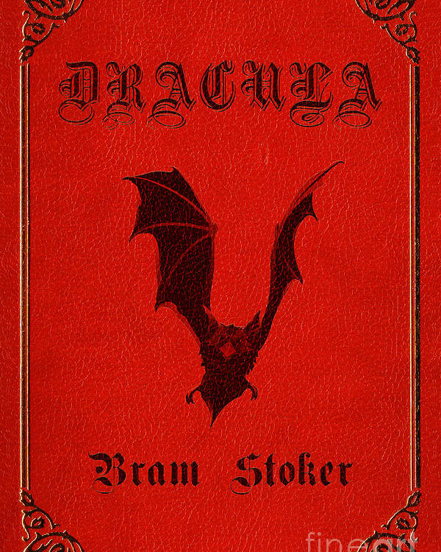

**HISTORY:**

**Tittle:** Guns, Germs, and Steel

Write: Book by Jared Diamond

**Discription:** Guns, Germs, and Steel: The Fates of Human Societies is a 1997 transdisciplinary non-fiction book by Jared Diamond. In 1998, it won the Pulitzer Prize for general nonfiction and the Aventis Prize for Best Science Book.

Year: 1997

[**Original language**](https://www.google.com/search?rlz=1C1GCEU_enPK864PK864&cs=0&sxsrf=ALiCzsZG5bHJNHQtkNBj4GLc7VjVSV0fIw:1659713640485&q=guns,+germs,+and+steel+original+language&stick=H4sIAAAAAAAAAOPgE-LQz9U3KMwxStcSy0620k_Kz88GE1Y5iXnppYnpqYtYNdJL84p1FNJTi3KBVGJeikJxSWpqjkJ-UWZ6Zl5ijgJMKQDXa9-nTwAAAA&sa=X&ved=2ahUKEwiMx-CPg7D5AhWTi_0HHfSCC0sQ6BMoAHoECF0QAg)**:**English

Image:

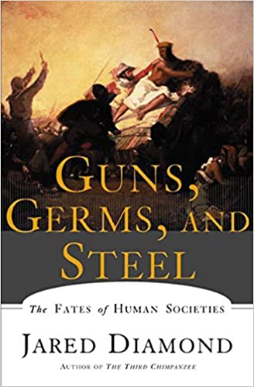

**HISTORY:**

**Tittle:** 1491: New Revelations of the Americas Before Columbus.

Write: Book by Charles C. Mann

Discription: 1491: New Revelations of the Americas Before Columbus is a 2005 non-fiction book by American author and science writer Charles C. Mann about the pre-Columbian Americas.

Year: 2005

[**Pages**](https://www.google.com/search?rlz=1C1GCEU_enPK864PK864&cs=0&sxsrf=ALiCzsZNdJR9hBcD5FipNYd7Uqr6c2D58A:1659713842129&q=1491:+new+revelations+of+the+americas+before+columbus+pages&sa=X&ved=2ahUKEwjch_Tvg7D5AhVGiP0HHeR7CsgQ6BMoAHoECFwQAg)**:**xii, 465 p.: ill., maps (1st ed.)

IMAGE:

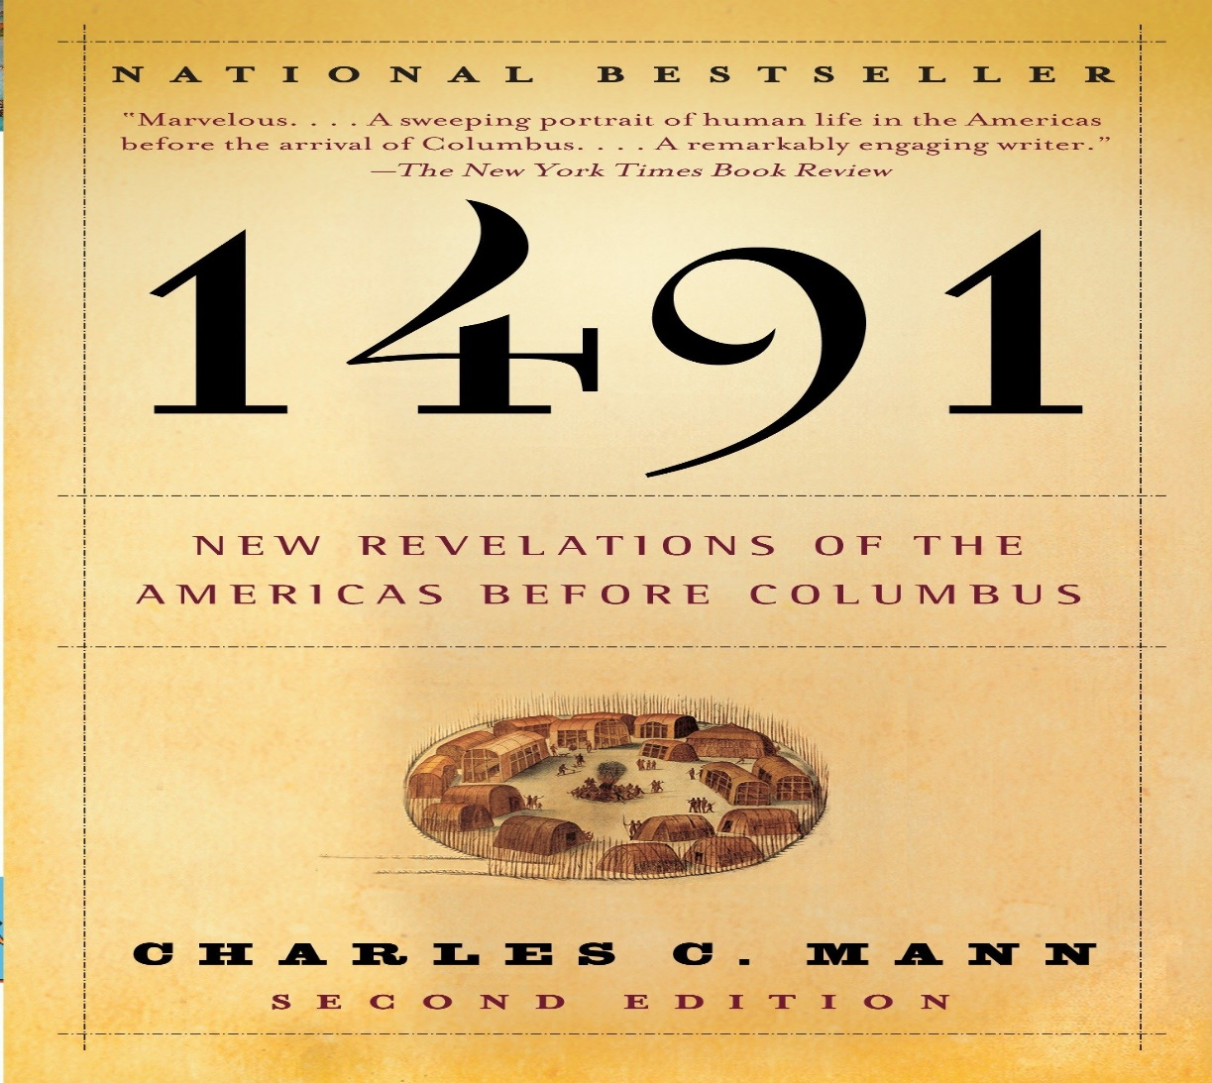

**HISTORY:**

**Tittle:** Genghis Khan and the Making of the Modern World.

Write: Book by Jack Weatherford

Discription: Genghis Khan and the Making of the Modern World is a history book written by Jack Weatherford, Dewitt Wallace Professor of Anthropology at Macalester College. It is a narrative of the rise and influence of Genghis Khan and his successors, and their influence on European civilization.

Year: March 16, 2004

[**Genre**](https://www.google.com/search?rlz=1C1GCEU_enPK864PK864&cs=0&sxsrf=ALiCzsYi-aEAgec549u6Zmxap-sOKfiGFA:1659714032079&q=genghis+khan+and+the+making+of+the+modern+world+genre&stick=H4sIAAAAAAAAAOPgE-LUz9U3SDLKMM3QEs5OttJPys_PBhNW6al5RamLWE2BdHpGZrFCdkZinkJiXopCSUaqQm5idmZeukJ-GoSXn5JalKdQnl-Uk6IA1gcAYZLH_FoAAAA&sa=X&ved=2ahUKEwi1z73KhLD5AhVm_bsIHWUIDAQQ6BMoAHoECFYQAg)**:**Biography

[**Pages**](https://www.google.com/search?rlz=1C1GCEU_enPK864PK864&cs=0&sxsrf=ALiCzsYi-aEAgec549u6Zmxap-sOKfiGFA:1659714032079&q=genghis+khan+and+the+making+of+the+modern+world+pages&sa=X&ved=2ahUKEwi1z73KhLD5AhVm_bsIHWUIDAQQ6BMoAHoECFQQAg)**:**312

**IMAGE:**

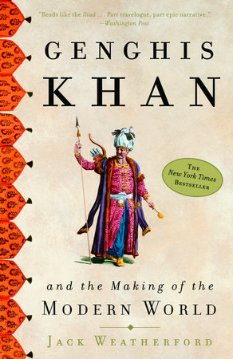

**HISTORY:**

**Tittle:** The Guns of August

Write: Book by Barbara W. Tuchman

DISCRIPTION: The Guns of August is a volume of history by Barbara W. Tuchman. It is centered on the first month of World War I. After introductory chapters, Tuchman describes in great detail the opening events of the conflict. Its focus then becomes a military history of the contestants, chiefly the great powers.

YEAR: 1962

[**Pages**](https://www.google.com/search?rlz=1C1GCEU_enPK864PK864&cs=0&sxsrf=ALiCzsaMGPyJG46tIYBn4QGW4N-kcP3A5A:1659714216377&q=the+guns+of+august+pages&sa=X&ved=2ahUKEwi4sq6ihbD5AhWOi_0HHWkvCKIQ6BMoAHoECGQQAg)**:**511

[**Awards**](https://www.google.com/search?rlz=1C1GCEU_enPK864PK864&cs=0&sxsrf=ALiCzsaMGPyJG46tIYBn4QGW4N-kcP3A5A:1659714216377&q=the+guns+of+august+awards&stick=H4sIAAAAAAAAAOPgE-LUz9U3MDYuNi7Tks1OttJPLE8sSoGQ8eWZeXmpRVZgTvEiVsmSjFSF9NK8YoX8NIXE0vTS4hIFiBwAZnsCVUgAAAA&sa=X&ved=2ahUKEwi4sq6ihbD5AhWOi_0HHWkvCKIQ6BMoAHoECGEQAg)**:**[Pulitzer Prize for General Nonfiction](https://www.google.com/search?rlz=1C1GCEU_enPK864PK864&cs=0&sxsrf=ALiCzsaMGPyJG46tIYBn4QGW4N-kcP3A5A:1659714216377&q=Pulitzer+Prize+for+General+Nonfiction&stick=H4sIAAAAAAAAAOPgE-LUz9U3MDYuNi5TAjMNLc2y87Rks5Ot9BPLE4tSIGR8eWZeXmqRFZhTvIhVNaA0J7OkKrVIIaAosypVIS2_SME9FagiMUfBLz8vLTO5JDM_bwcr4y52Jg4GAOIBa-1nAAAA&sa=X&ved=2ahUKEwi4sq6ihbD5AhWOi_0HHWkvCKIQmxMoAXoECGEQAw)

IMAGE:

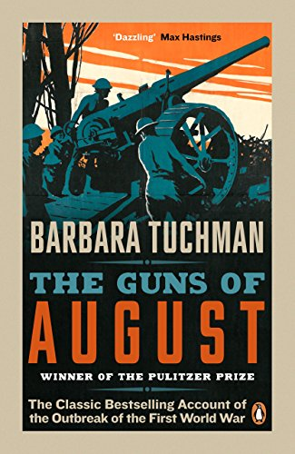

**Fiction:**

**Tittle:** Pride and Prejudice

Write: Novel by Jane Austen

DISCRIPTION: Pride and Prejudice is an 1813 novel of manners by Jane Austen. The novel follows the character development of Elizabeth Bennet, the dynamic protagonist of the book who learns about the repercussions of hasty judgments and comes to appreciate the difference between superficial goodness and actual goodness.

**YEAR:**January 28, 1813

[**Original language**](https://www.google.com/search?rlz=1C1GCEU_enPK864PK864&cs=0&q=pride+and+prejudice+original+language&stick=H4sIAAAAAAAAAOPgE-LRT9c3NErKiy-sMozXEstOttJPys_PBhNWOYl56aWJ6amLWFULijJTUhUS81IUCopSs0pTMpNTFfKLMtMz8xJzFGDqAFbkmEtQAAAA&sa=X&ved=2ahUKEwjMleLHxcH5AhVrg_0HHa8tAXYQ6BMoAHoECF4QAg)**:**English

[**Genres**](https://www.google.com/search?rlz=1C1GCEU_enPK864PK864&cs=0&q=pride+and+prejudice+genres&stick=H4sIAAAAAAAAAOPgE-LRT9c3NErKiy-sMozXEs5OttJPys_PBhNW6al5RamLWKUKijJTUhUS81IUCopSs0pTMpNTFcByxQD6DWDkQgAAAA&sa=X&ved=2ahUKEwjMleLHxcH5AhVrg_0HHa8tAXYQ6BMoAHoECGAQAg)**:**Fiction, Romance novel

IMAGE:

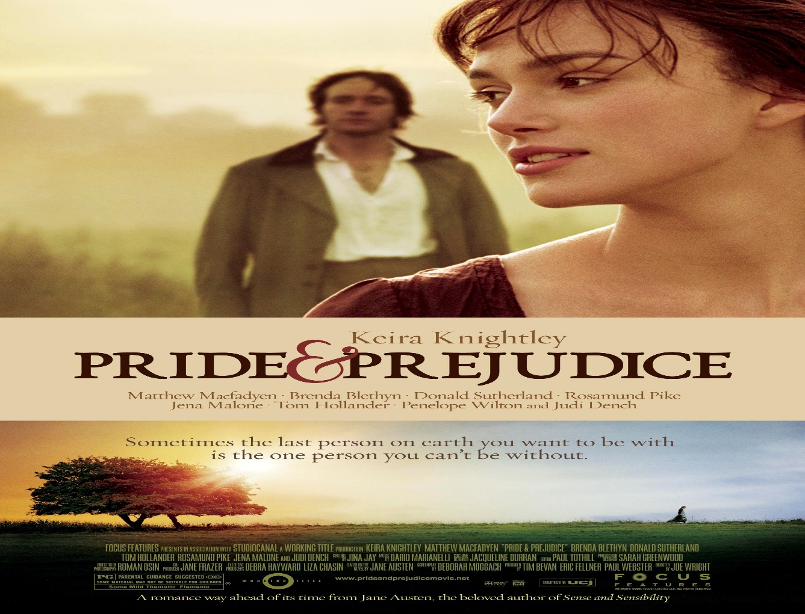

**Fiction:**

**Tittle:** Nineteen Eighty-Four

Write: Novel by George Orwell

**DISCRIPTION:** Nineteen Eighty-Four is a dystopian social science fiction novel and cautionary tale written by the English writer George Orwell. It was published on 8 June 1949 by Secker & Warburg as Orwell's ninth and final book completed in his lifetime.

Year:June 8, 1949

[**Original language**](https://www.google.com/search?rlz=1C1GCEU_enPK864PK864&cs=0&q=nineteen+eighty-four+original+language&stick=H4sIAAAAAAAAAOPgE-LQz9U3yKmyLNYSy0620k_Kz88GE1Y5iXnppYnpqYtY1fIy81JLUlPzFFIz0zNKKnXT8kuLFPKLMtMz8xJzFGAKAUua_fZNAAAA&sa=X&ved=2ahUKEwie-vL2x8H5AhUI_rsIHS5FD-sQ6BMoAHoECFYQAg)**:**English

[**Awards**](https://www.google.com/search?rlz=1C1GCEU_enPK864PK864&cs=0&q=nineteen+eighty-four+awards&stick=H4sIAAAAAAAAAOPgE-LQz9U3yKmyLNaSzU620k8sTyxKgZDx5Zl5ealFVmBO8SJW6bzMvNSS1NQ8hdTM9IySSt20_NIiBYgsACFuFLNJAAAA&sa=X&ved=2ahUKEwie-vL2x8H5AhUI_rsIHS5FD-sQ6BMoAHoECFcQAg)**:**[Prometheus Hall of Fame Award](https://www.google.com/search?rlz=1C1GCEU_enPK864PK864&cs=0&q=Prometheus+Hall+of+Fame+Award&stick=H4sIAAAAAAAAAOPgE-LQz9U3yKmyLFYCs8wMLc20ZLOTrfQTyxOLUiBkfHlmXl5qkRWYU7yIVTagKD83tSQjtbRYwSMxJ0chP03BLTE3VcERpGAHK-MudiYOBgD1IogtXQAAAA&sa=X&ved=2ahUKEwie-vL2x8H5AhUI_rsIHS5FD-sQmxMoAXoECFcQAw)

IMAGE:

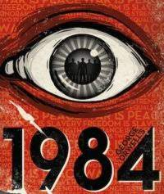

**Fiction:**

**Tittle:** The Seven Husbands of Evelyn Hugo

Write: Novel by Taylor Jenkins Reid

DISCRIPTION: The Seven Husbands of Evelyn Hugo is a historical fiction novel by American author Taylor Jenki ns Reid and published by Atria Books in 2017. The novel tells the story of the fictional Old Hollywood star Evelyn Hugo, who at age 79 gives a final interview to an unknown journalist, Monique Grant.

Year: June 13, 2017

[**Original language**](https://www.google.com/search?rlz=1C1GCEU_enPK864PK864&cs=0&q=the+seven+husbands+of+evelyn+hugo+original+language&stick=H4sIAAAAAAAAAOPgE-LVT9c3NExPt0zKqjKp1BLLTrbST8rPzwYTVjmJeemliempi1iNSzJSFYpTy1LzFDJKi5MS81KKFfLTFIACOZUgofR8hfyizPTMvMQcBZguAPLwKblfAAAA&sa=X&ved=2ahUKEwiA9KrxyMH5AhUBh_0HHUNwAXQQ6BMoAHoECEQQAg)**:**English

[**Genres**](https://www.google.com/search?rlz=1C1GCEU_enPK864PK864&cs=0&q=the+seven+husbands+of+evelyn+hugo+genres&stick=H4sIAAAAAAAAAOPgE-LVT9c3NExPt0zKqjKp1BLOTrbST8rPzwYTVumpeUWpi1g1SjJSFYpTy1LzFDJKi5MS81KKFfLTFIACOZUgofR8BbDKYgB3V7jCUQAAAA&sa=X&ved=2ahUKEwiA9KrxyMH5AhUBh_0HHUNwAXQQ6BMoAHoECEYQAg)**:**Novel, Romance novel, Historical Fiction, Psychological Fiction

IMAGE:

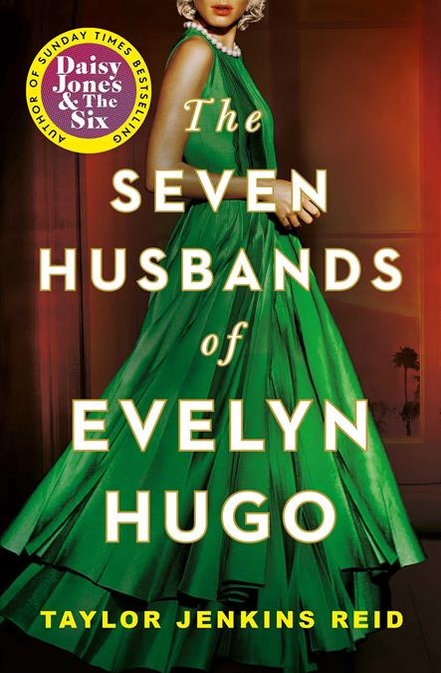

**Fiction:**

**Tittle:** Where the Crawdads Sing

Write: Novel by Delia Owens

DISCRIPTION: Where the Crawdads Sing is a 2018 coming-of-age murder mystery novel by American author Delia Owens. The story follows two timelines that slowly intertwine. The first timeline describes the life and adventures of a young girl named Kya as she grows up isolated in the marshes of North Carolina.

Year: August 14, 2018

[**Original language**](https://www.google.com/search?rlz=1C1GCEU_enPK864PK864&cs=0&q=where+the+crawdads+sing+original+language&stick=H4sIAAAAAAAAAOPgE-LVT9c3NMwwqEyOT4430RLLTrbST8rPzwYTVjmJeemliempi1g1yzNSi1IVSjJSFZKLEstTElOKFYoz89IV8osy0zPzEnMUYGoBYzlbd1UAAAA&sa=X&ved=2ahUKEwjhxsnuycH5AhV1gv0HHZ4_BtQQ6BMoAHoECFwQAg)**:**English

[**Genres**](https://www.google.com/search?rlz=1C1GCEU_enPK864PK864&cs=0&q=where+the+crawdads+sing+genres&stick=H4sIAAAAAAAAAOPgE-LVT9c3NMwwqEyOT4430RLOTrbST8rPzwYTVumpeUWpi1jlyjNSi1IVSjJSFZKLEstTElOKFYoz89IVwPLFAAjrCg5HAAAA&sa=X&ved=2ahUKEwjhxsnuycH5AhV1gv0HHZ4_BtQQ6BMoAHoECGEQAg)**:**Novel, Bildungsroman, Mystery, Literary fiction, Romance novel

Image:

